建構函數(Contructor)的依賴注入(Dependency Injection)
注入原始值(int)和字串(String)的值
我們可以通過建構函數注入依賴。
<bean>的<constructor-arg>子元素用於建構函數注入。
這裡我們要注入
讓我們看一下注入原始值和基於字串的值的簡單範例。我們在這裡建立了三個文件：
- MyEmployee.java (Model)
- applicationContext.xml (bean 屬性設定檔案)
- Spring Controller

Model:
package model;

public class MyEmployee {
private int id;
private String name;

public MyEmployee() {
System.out.println("define default constructor");
}

public MyEmployee(int id) {
this.id = id;
}

public MyEmployee(String name) {
this.name = name;
}

public MyEmployee(int id, String name) {
this.id = id;
this.name = name;
}

public void show() {
System.out.println(id + " " + name);
}

public int getId() {
return id;
}

public void setId(int id) {
this.id = id;
}

public String getName() {
return name;
}

public void setName(String name) {
this.name = name;
}

@Override
public String toString() {
return "MyEmployee [id=" + id + ", name=" + name + "]";
}

}
建立 src/main/resources 資料夾
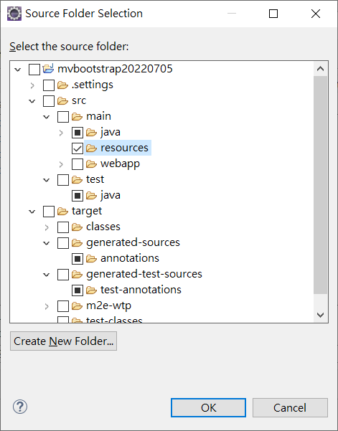

產生一個applicationContext.xml
<?xml version="1.0" encoding="UTF-8"?>
<beans xmlns="http://www.springframework.org/schema/beans"
xmlns:xsi="http://www.w3.org/2001/XMLSchema-instance"
xmlns:p="http://www.springframework.org/schema/p"
xsi:schemaLocation="http://www.springframework.org/schema/beans
http://www.springframework.org/schema/beans/spring-beans-3.0.xsd">

<bean id="emp" class="model.MyEmployee">
<constructor-arg value="10" type="int"></constructor-arg>
<constructor-arg value="Sunny"></constructor-arg>
</bean>

</beans>

Spring Controller:

import org.springframework.context.ApplicationContext;
import org.springframework.context.support.ClassPathXmlApplicationContext;
import org.springframework.stereotype.Controller;
import org.springframework.ui.ModelMap;
import org.springframework.web.bind.annotation.RequestMapping;
import org.springframework.web.bind.annotation.RequestMethod;

import model.MyEmployee;
@Controller
public class EmployeeController {

@RequestMapping(value="/empobj",method = RequestMethod.GET)
public String myEmployeeObj(ModelMap model) {
ApplicationContext context = new ClassPathXmlApplicationContext("applicationContext.xml");
MyEmployee obj = (MyEmployee) context.getBean("emp");

model.addAttribute("greeting", obj.toString());

return "emp";
}

}

View emp.jsp

<%@ page language="java" contentType="text/html; charset=UTF-8"
pageEncoding="UTF-8"%>
<!DOCTYPE html>
<html>
<head>
<meta charset="UTF-8">
<title>Spring DI Bean</title>
</head>
<body>
Controller : ${greeting}
</body>
</html>

